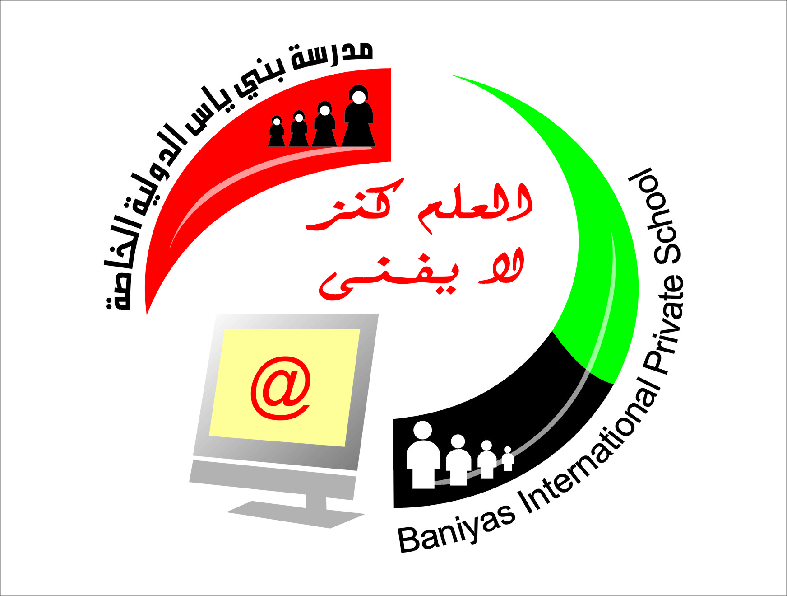
Subject computer

Department of computers
Baniyas International Private School
School Year 2018-2019
المرحلة الثانوية ( 10-12) بنين+بنات

مدرسة بني ياس الدولية الخاصة
المرحلة الاساسية ( 1-9) بنين+بنات
رياض الاطفال (روضة1+روضة 2)
Revision sheet for grade 9
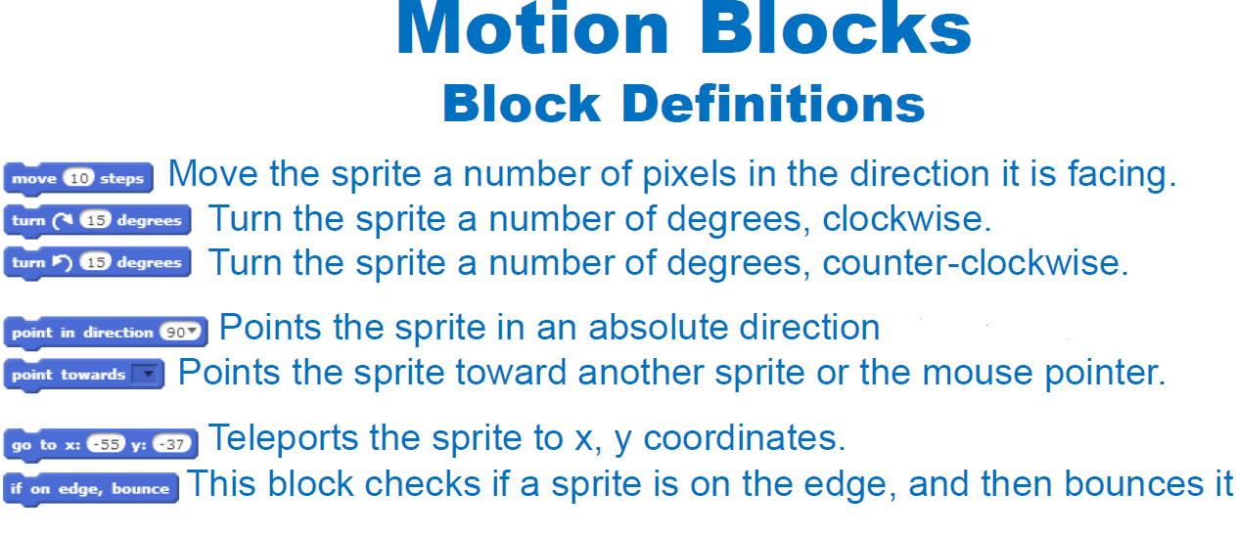

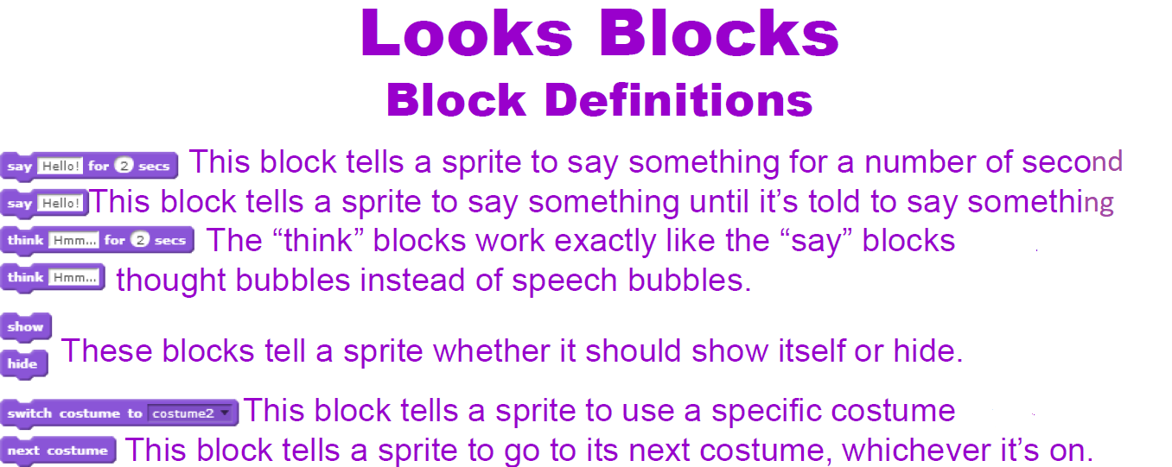

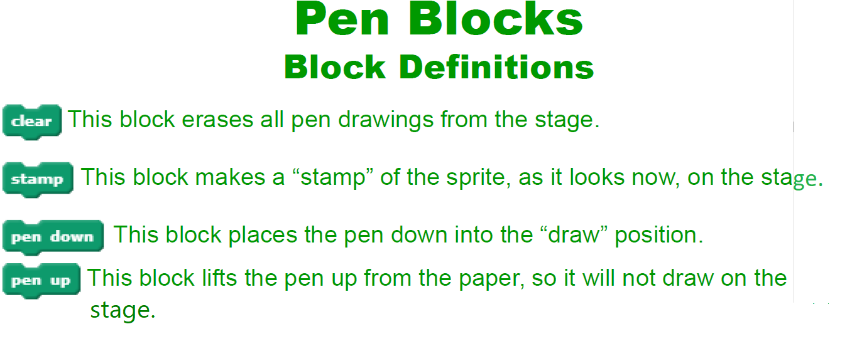

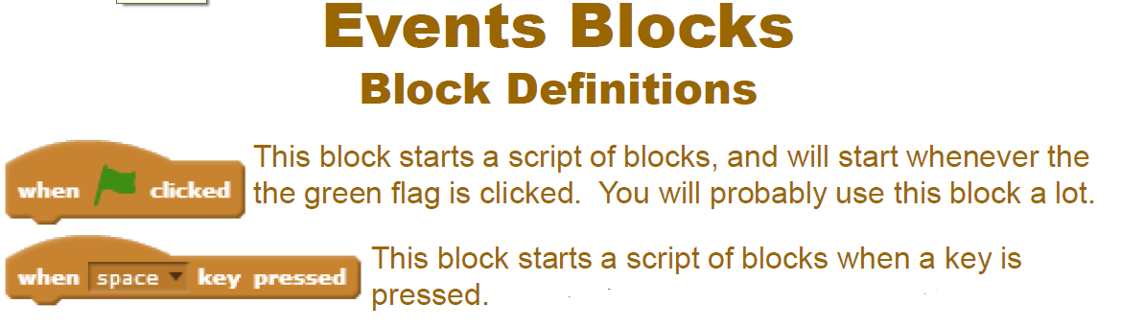

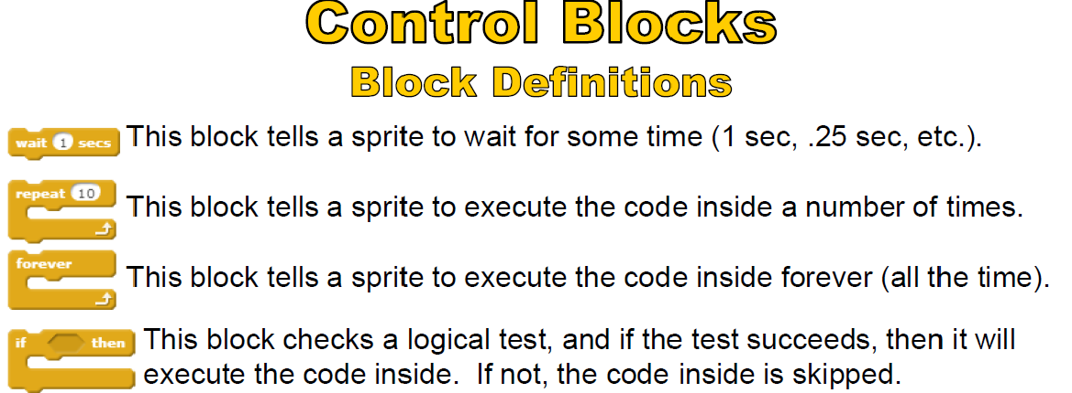

Scratch life cycle.
- What is scratch?
SCRATCH is a programming language that lets you create your own interactive stories, animations, games, music, and art.
- Why we use online scratch?
We use online scratch to create games moves and share with others use it to learn.
- Who is scratch for?
Scratch is for young people age 9 to above.
- Advantages of scratch?
1 thinks faster.
2 solve problems easily.
3 Cooperative learning.
- Select from multiple choices.

- What section do you find things to start scripts?
a: Events b: Operators c: Data
- In motion, what type of block do you use to stop sprites coming off the screen?
a: if on edge, set y to change.
b: Set rotation style .
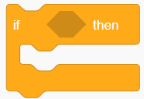
c: if on edge, bounce.
- What blocks do you use for ?
a: Sensing.
b: data.
c: control.
- Scratch is for making programs and sharing your creations?
a: true .
b: false.
c: neither.
- What can costumes do?
a: make more sprites.
b: create blocks.
c: make awesome animations when the right block is used.

- What is motion used for?
a: taking pictures.
b: Moves sprites, changes angles and changes X and Y values.
c: to paint backdrops.
- Complete this sentence-scratch is useful for ________.
a: create movies and games .
b: creating lists.
c: making scripts.
- When clicking on my stuff button, what can you see?
a: scripts
b: previous all projects.
c: the views.
- What is the name of the cat on Scratch?
a: Steve.
b: kitty cat.
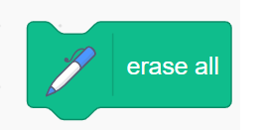
c: sprite 1.
10.What blocks do you use for ?
a: Sensing.
b: pen.
c: control.

- Main parts of scratch
Background area
Sprite area
Stage
Block or code palate
Coding area
Start
stop
zoon in
zoom out
- What is backpack?
The backpack is a feature of the Scratch 2.0 project editor that allows users to drag and drop costumes, sprites, sounds, and scripts from other projects into it and then drag and drop them easily into their project

