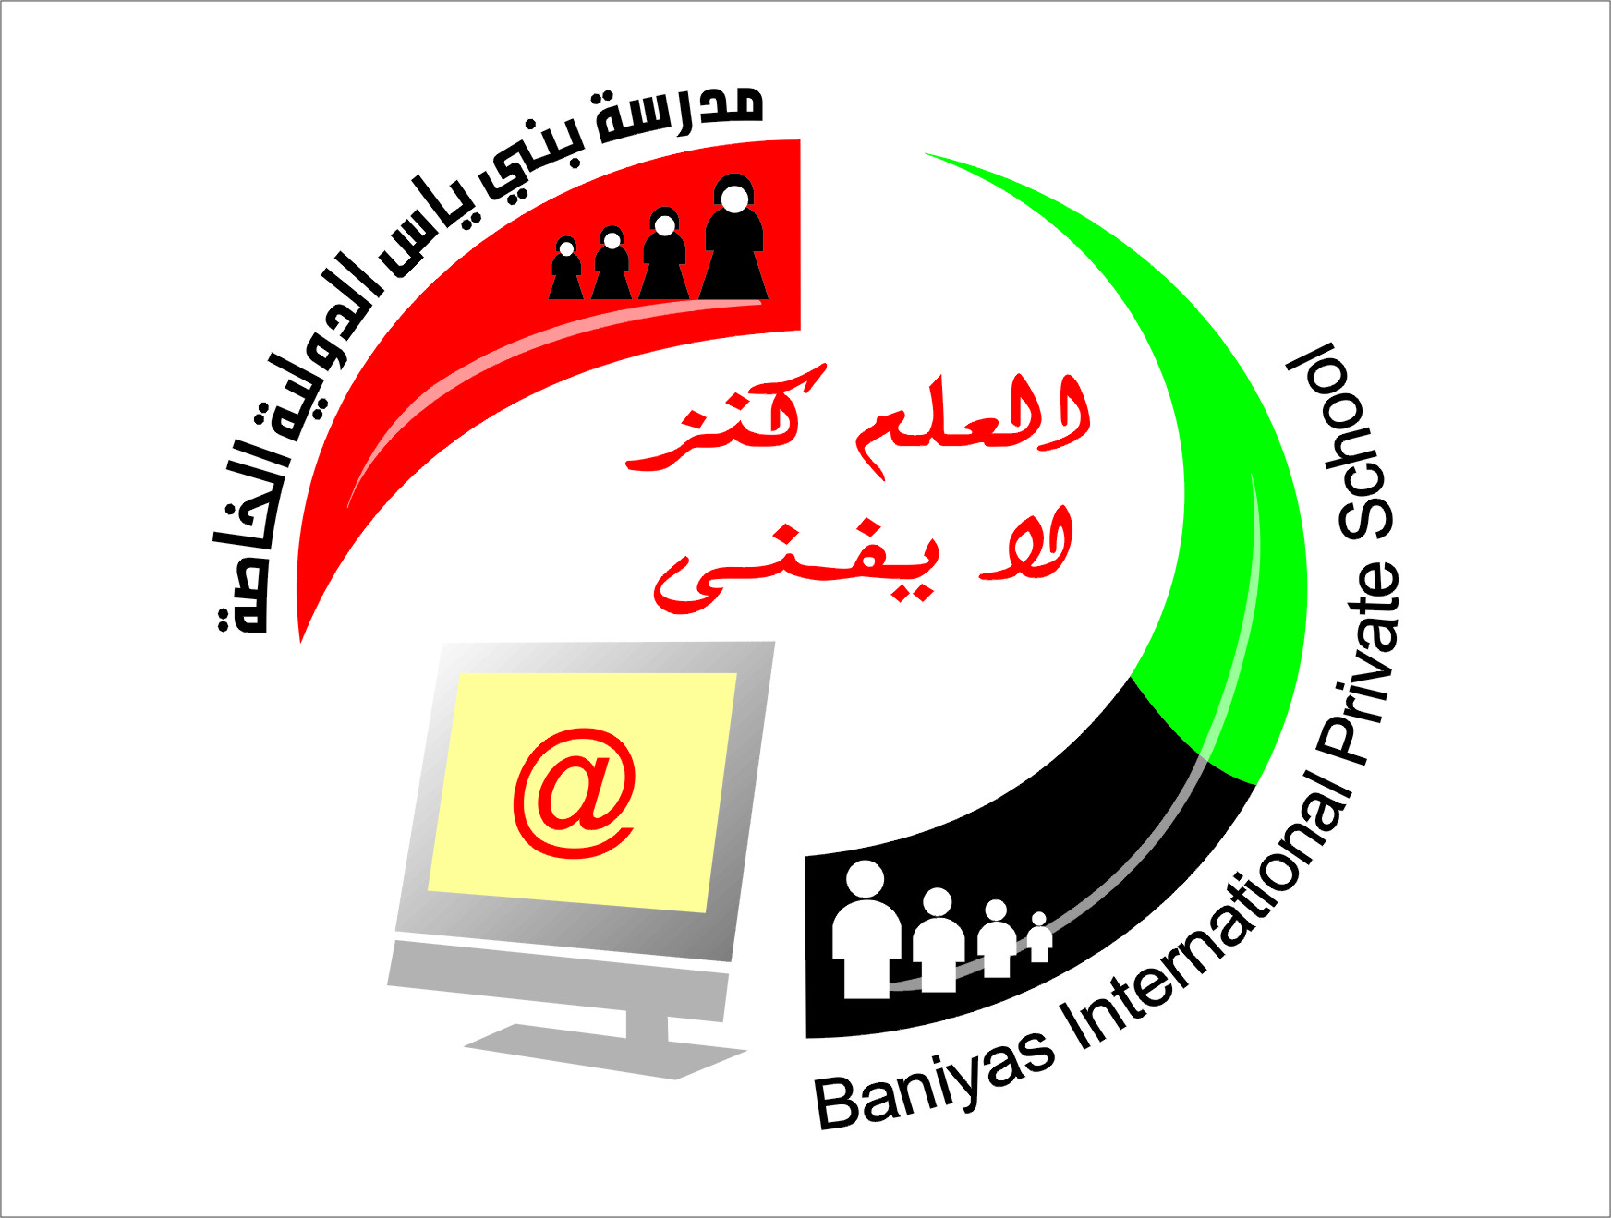
Subject computer

Department of computers
Baniyas International Private School
School Year 2018-2019
المرحلة الثانوية ( 10-12) بنين+بنات

مدرسة بني ياس الدولية الخاصة
المرحلة الاساسية ( 1-9) بنين+بنات
رياض الاطفال (روضة1+روضة 2)
Revision sheet for grade 7

- Select from multiple choices.
- What is motion used for?
a: taking pictures
b: Moves sprites, changes angles and changes X and Y values.
c: to paint backdrops
- Complete this sentence-scratch is useful for ________.
a: create movies and games
b: creating lists
c: making scripts
- When clicking on my stuff button, what can you see?
a: scripts
b: previous all projects
c: the views
- What is the name of the cat on Scratch?
a: Steve
b: kitty cat
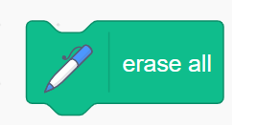
c: sprite 1
- This block is use for?
a: Sensing
b: remove(pen)
c: control
- Scratch is useful for…………….
a: students
b: moms
c: Dads
- You can move ………. On stage.
a: tool
b: sprite
c: event
- We can use scratch in.
a: mobile
b: computer
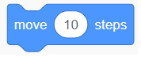
c: tablet
- This block is use for ?
a: Event b: move c: Data
10. In motion, what type of block do you use to stop sprites coming off the screen?
a: if on edge, set y to
b: Set rotation style
c: if on edge, bounce
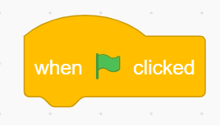
11. This block is use for ?
a: start
b: stop
c: control
12. Scratch is for making programs and sharing your creations?
a: true
b: false
c: neither
13.We use…….. Scratch to share our project?
a: offline
b: home
c: online
- Fill in the blanks.
Movies, games, account, ID, sprits, background, people
Think, language, movies, online, projects ,helpful
- We use scratch to make movies and games.
- We need account or ID to use online scratch.
- We use different sprites in scratch.
- We design our own background in scratch.
- Scratch is for young people age 9 to above.
- Scratch helps us to think.
- Scratch is a language which we use to create movies and games.
- We can use scratch online.
- We can share our projects with our friends.
- Scratch is helpful in critical thinking

- True and false
- There is no sprite in scratch. F
- Scratch is very easy language. T
- We will make games in scratch. T
- We use sound in scratch. T
- Scratch is online software. T
- Scratch is the language for below 9 kids. F
- Scratch user friendly language. T
- There is no background in scratch. F
- Scratch is very difficult language. F
- We will make software in scratch. F
- We use sprite in scratch. T
- Scratch is online software. F
- If you do not have scratch account what you will click?
√

- If you have scratch account then what you write in it?
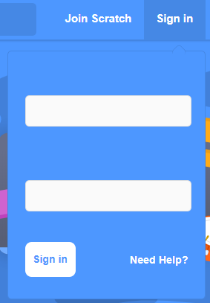
ID
password

- How to make online scratch account, arrange the steps.
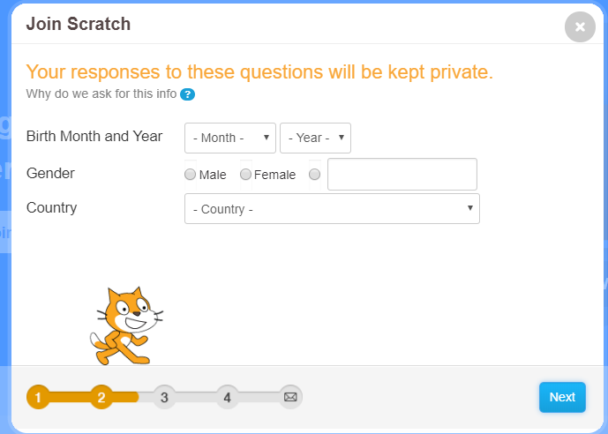
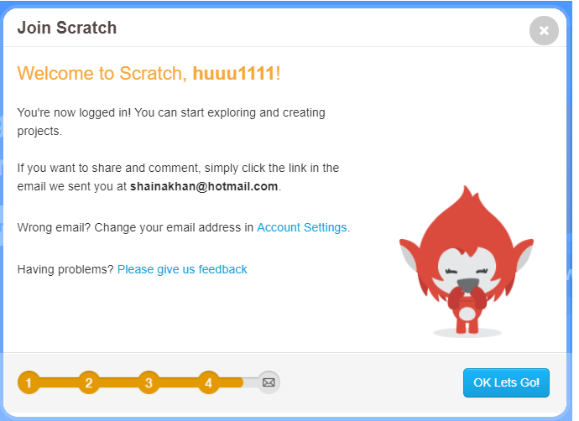

2
4

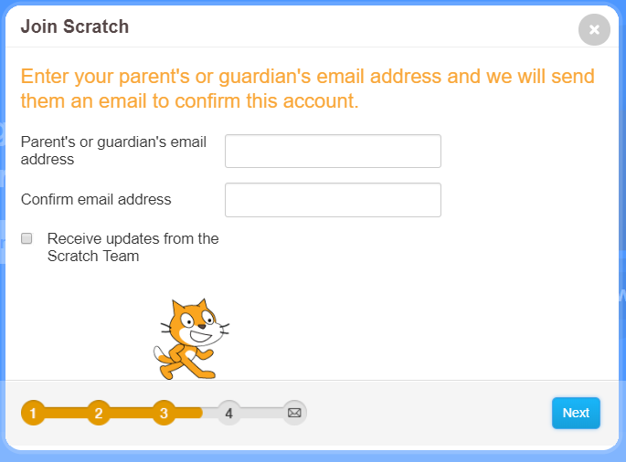
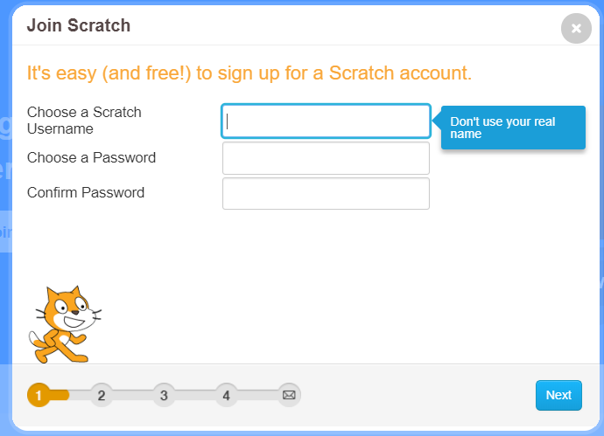

3
1

- This is the main screen of scratch write main parts of it.

8
7
2

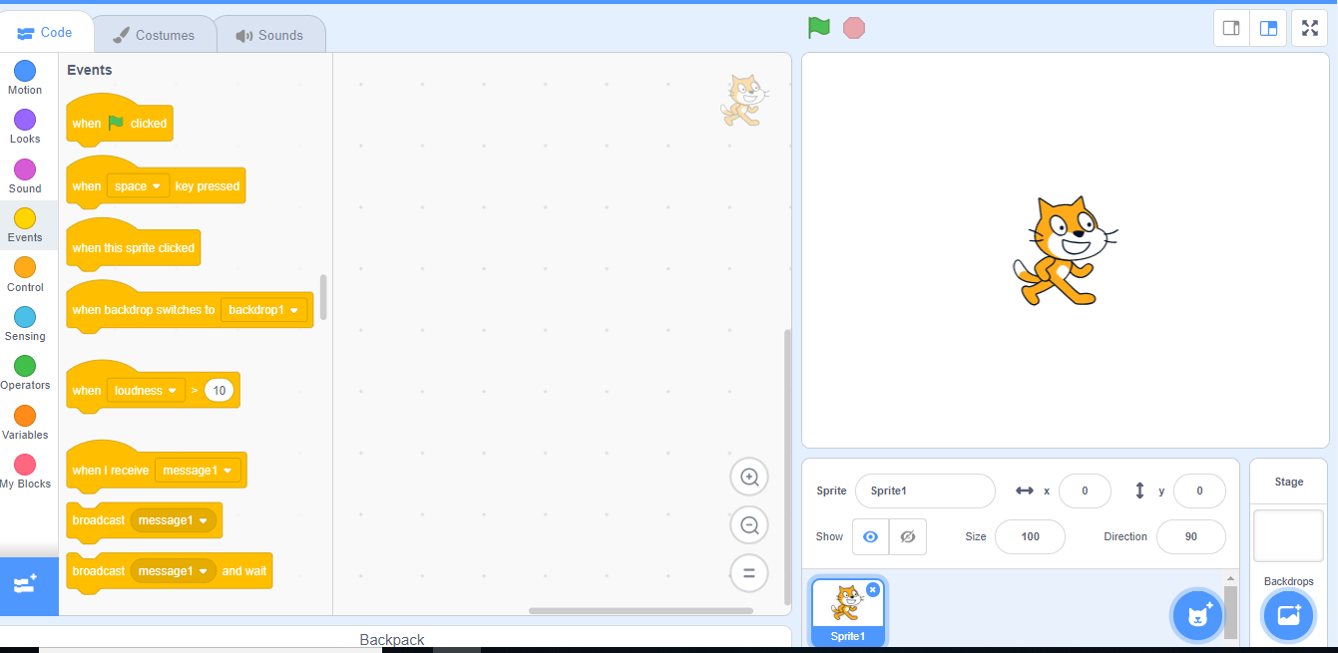

5
3

6
1
4

Background area
Sprite area

start
stage

Block palette
Coding area

Coding button
Zoon in

- Match the answer.
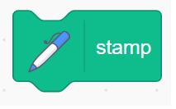 | Wait for second
 | If on corner bounce
 | Stamp tool in pan
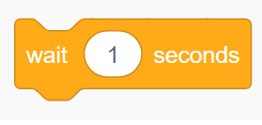 | Move 10 step
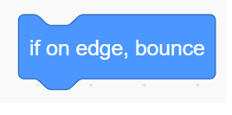 | Remove all in stage

 | Wait for second
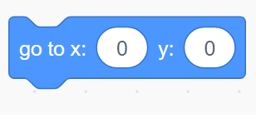 | If on corner bounce
 | Use to start program
 | Show x and y position
 | Remove all in stage

- Explain these blocks.
1.

This block starts a script of blocks, and will start whenever the green flag is clicked.
2.

This block checks if a sprite is on the edge, and then bounces it off.
3.

Teleports the sprite to x, y coordinates.

Move the sprite a number of pixels in the direction it is facing.
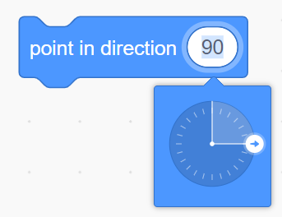

Points the sprite in an absolute direction

