Academic Year 2018-2019 العام الدراسي Grade: 6
Subject: computer | Computer revision sheets
United Arab Emirates  Department of Education and Knowledge  Bani Yas International Private School |  | دولة الإمارات العربية المتحدة  دائرة التعليم والمعرفة  مدرسة بني ياس الدولية الخاصة
MS Access
Data base :
A set of interrelated data stored in a single frame
Table :
Consist of a set of interrelated records with a common relationship
Record:
Consist of a set of interrelated fields ,with common relationship
Fields :
Consist of a set of data
Access objects
- Tables
- Reports
- Query
- Forms
- macro
Data base types of data
- 1- text : accept data consisting of letters and numbers
- 2- number : accept data consisting of integers numbers such as 3,5or real numbers such as 3.5
- 3- memo : accept data consisting of letters and numbers more than one line
- 4- currency : accept numbers plus currency symbol such as 34$
- 5- date/ time : accept different forms of date and time
- 6- Boolean (yes/no) : accept the data which has the correct or wrong value

The benefits of database
- 1-store large amount of data in small place in computer
- 2- quick access to information
- 3- the ability to add ,modify or delete data
- 4- extract reports quickly and easily

Design and Create Tables
How to create and design a table ?
1- creating a table using design view
2- creating a table using a datasheet
1- creating a table using design view
1- run MS Access
2- click on view design in tool bar
3- write the name of the table and click ok
4- Enter fields names and data type and click close table and save the last changes
Quires
- In Microsoft access all of your data is stored in one or more tables .
- You can use query to display that data whichever way you want
- A query allow you to sort the data by one or more fields ,such as last name or first name or age
- You can specify criteria in your query to filter the results shown
How we can design a query ?
- 1-click on create menu
- 2- you have 2 ways to create query :
- A- query wizard B-query design
in the table below write the data type for each field in the second column :
( short text – number –date/time- currency –long text )
Type | Field name
Number | Student no
Short text | Student name
Date / time | Birthday
Long text | Address
Currency | Income

match the icons to their functions:
Tables A set of interrelated data stored in a single frame
Database Consist of a set of interrelated records with a common relationship
Text accept data consisting of letters and numbers
Fields Consist of a set of data
Date/time accept different forms of date and time

State true or false
1-table is the main object in database ( true )
2-to create a table you have to click on create menu ( true )
3- to save a database click on file menu and choose open (false )
4- Record is Consist of a set of interrelated fields ,with common relationship ( true )
5- form is one of database objects ( true )

Write in down table Ms access main screen parts
( menu bar- title bar – status bar – access objects – record )

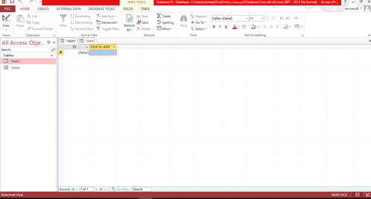
2
1
3
4
5

menu bar | 1
Access objects | 2
Record | 3
Title bar | 4
Status bar | 5
Complete the following sentence:
(database – table – number – currency -date/time )
- …………………Consist of a set of interrelated records with a common relationship
- ……………………A set of interrelated data stored in a single frame
- ……………. accept data consisting of integers numbers
- …………………….accept different forms of date and time
- ……………………….accept numbers plus currency symbol such as 34$
The answer :
1-Table
2-database
3-number
4- date /time
5-currency

