Academic Year 2018-2019 العام الدراسي Grade: 5
Subject: computer | Computer revision sheet

United Arab Emirates  Department of Education and Knowledge  Bani Yas International Private School | 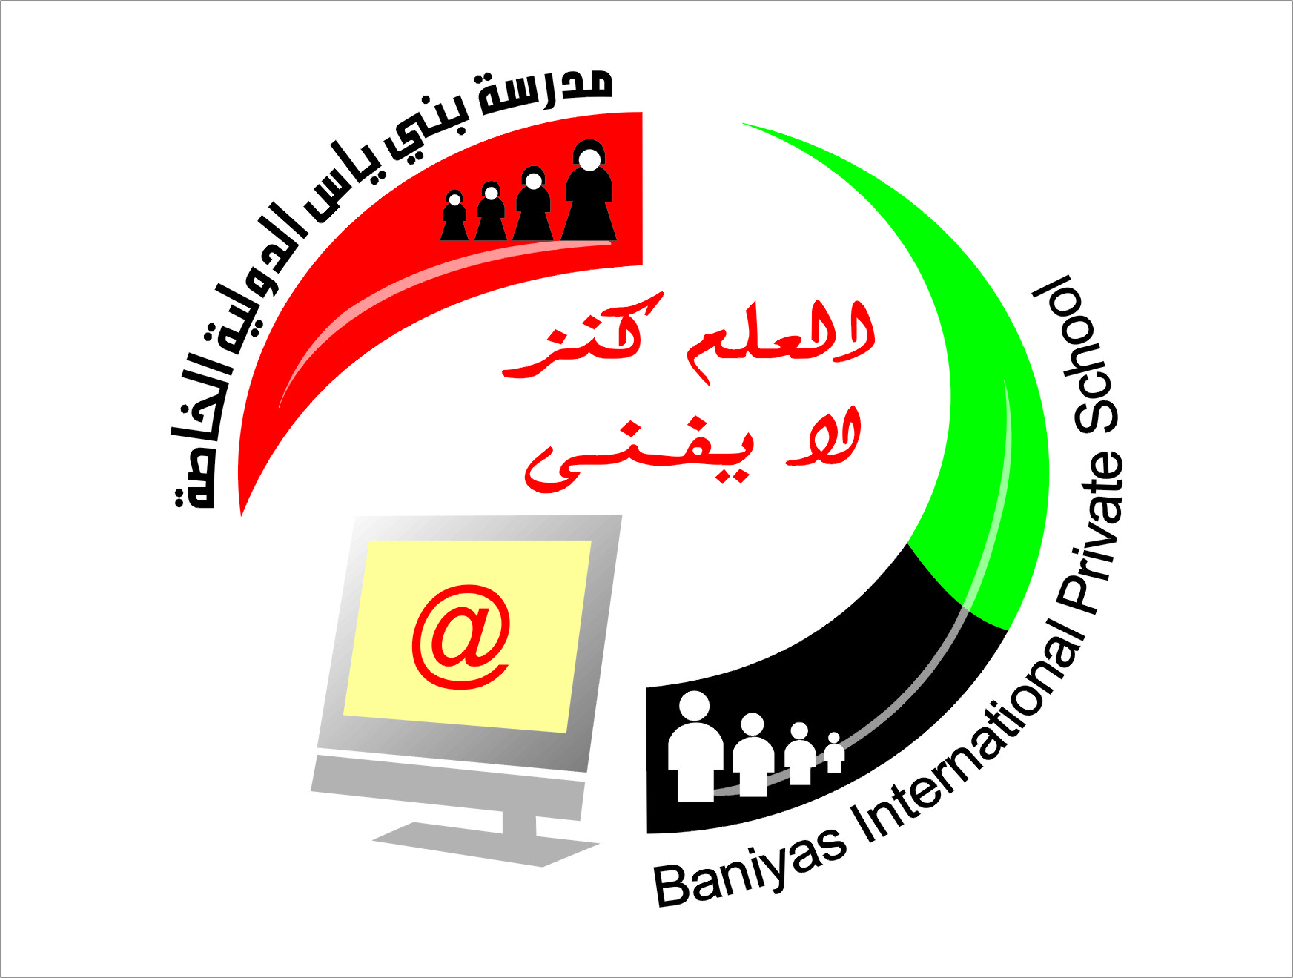 | دولة الإمارات العربية المتحدة  دائرة التعليم والمعرفة  مدرسة بني ياس الدولية الخاصة
– Write in down table power point main screen parts
( Menu bar – title bar – tool bar- work area – note area – status bar – outline pane )
11
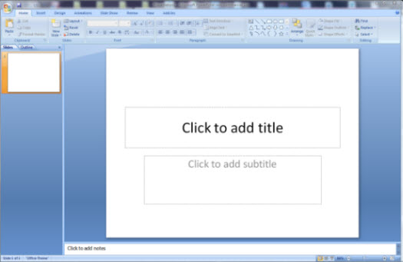
7
6
5
4
3
2

Title bar | 1
Menu bar | 2
Outline pane | 3
Note area | 4
Status bar | 5
Work area | 6
Tool bar | 7

– State whether true or false :
1-We use MS Power point to make a presentation ( true )
2-to insert new slide click insert menu and click new slide (true )
3- you cannot add video or audio to slide in power point (false )
4- to save presentation click on open tool ( false )
5- to delete slide right click on slide in slide pane and choose delete ( true )
6- to save a presentation in power point open file menu and choose save ( true )
7-power point is a presentation program ( true )
8 -you can insert picture in power point from design menu (false )

- Choose the correct answer :
1-to make text bold in slide click on ………….
( - - )
2- to insert table in slide open insert menu and choose………..
(picture – table – word art )
3- you can change slide background from …………
(design – insert –home ) menu
4- to save presentation click on ……………
(open – save – copy ) tool
5- to add motion effects in slideshow when you move one slide to next slide click on ………………
( transition – home- view )

steps to save apresentation in power point :
- Open file menu and choose save
- write file name for presentation
-click on save button

State 3 features for power point
- Design a slide including text ,pictures and video
- Insert transition to slides
- Add animation to slides

State the elements of the display and preview bar ?
- Slide show
- Slide sorter
- Normal view

Mention five slides type we can insert in power point ?
- Title slide
- Title and content
- Title only
- Two content
- Blank

