Academic Year 2018-2019 العام الدراسي Grade: 3
Subject: computer | Computer Revision sheets

United Arab Emirates  Department of Education and Knowledge  Bani Yas International Pr`ivate School | 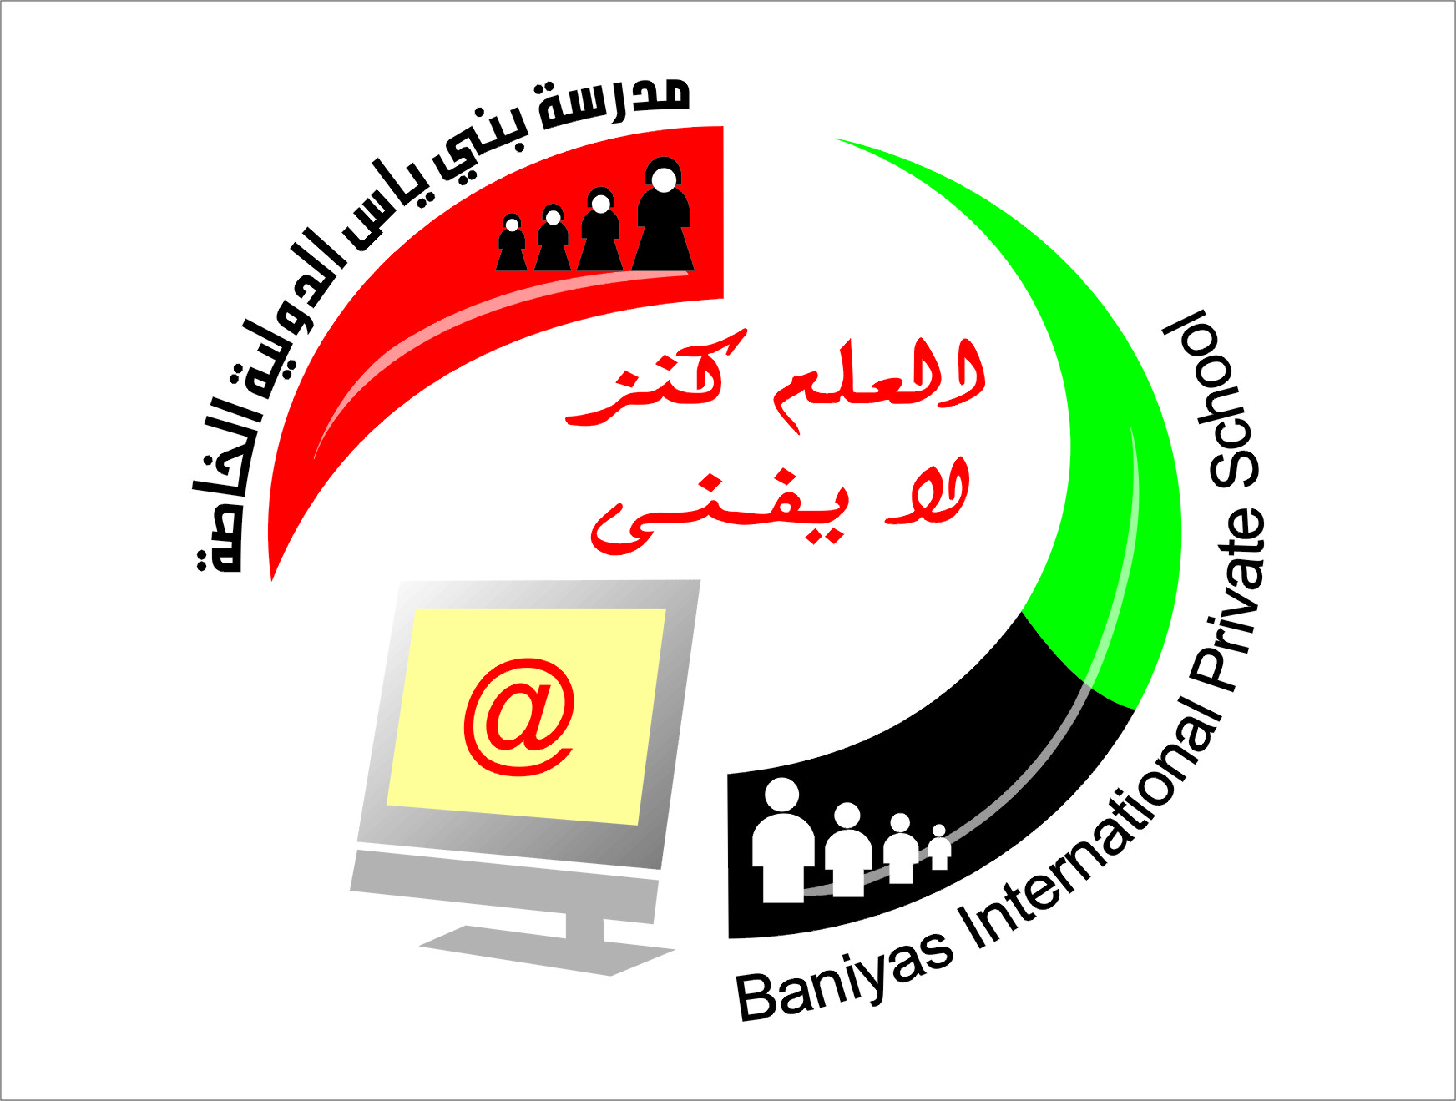 | دولة الإمارات العربية المتحدة  دائرة التعليم والمعرفة  مدرسة بني ياس الدولية الخاصة
Desktop Icons

My document
Recycle bin
My computer
My network places
Internet explorer
Google chrome

Fill in the blanks with answers :
1-To create folder on the desktop we click on ……………………, then we choose ……………………
re
2-To delete a selected folder press on ……………….key then click on …………….. then click on ……….
3-To change the folder name click on right click Then click on button ……………..
4-power point is …………………. Program
5- to insert new slide in power point click on insert menu and choose ……………….
6- to make text bold click on ……….. in font window
7- to start the show from beginning in power point presentation click on ……….. from keyboard
8- To save presentation open file menu and choose ……….
9- to close power point click on …………….. from keyboard
10-in power point you can insert table from ………. Menu
The answer :
- Right click – New
- Right click – delete –yes
- Rename
- Presentation
- New slide
- B
- F5
- Save
- ALT+F4
- Insert
– State whether true or false
1-to delete file click on delete from the keyboard ( true )
2- power point is a presentation program ( true )
3-you can insert picture in power point from design menu (false )
4-after you create a folder you cannot change name ( false )
5-the screen saver appears after a specific time of leaving the computer without doing any thing ( true )
6- folders it is the place where you save your files ( true )
7-to copy file click ctrl +x from the keyboard ( false )
8-you cannot restore file from recycle bin ( false )
9-to change the desktop background left click on the desktop and choose personalize ( true )
10- to save a presentation in power point open file menu and choose save ( true )

– Write in down table power point main screen parts
( Menu bar – title bar – tool bar- work area – outline pane-status bar )
11
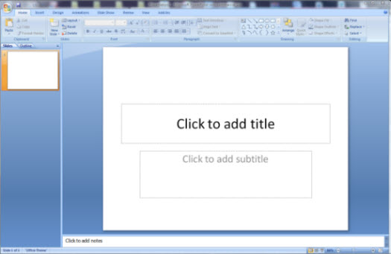
6
5
4
3
2

1 | Title bar
2 | Menu bar
3 | Outline Pane
4 | Work area
5 | Tool bar
6 | Status bar

