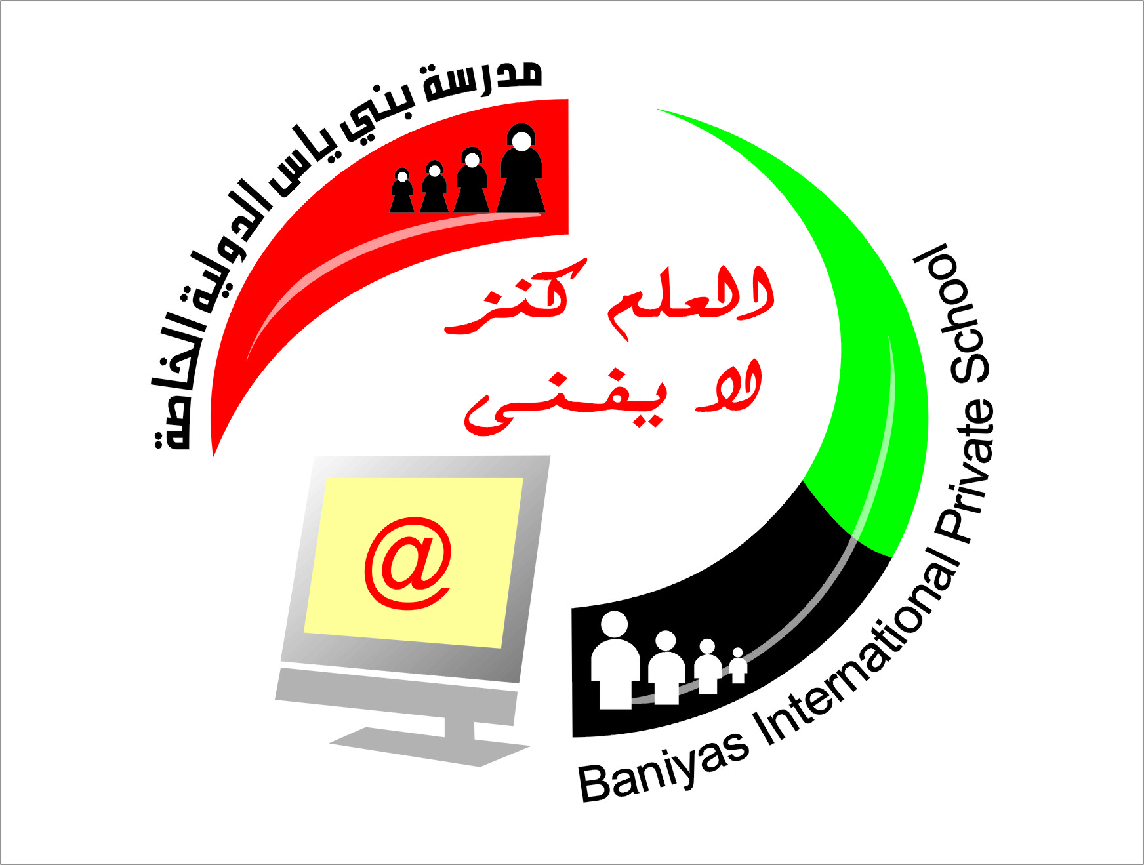
Subject computer

Department of computers
Baniyas International Private School
School Year 2018-2019
المرحلة الثانوية ( 10-12) بنين+بنات

مدرسة بني ياس الدولية الخاصة
المرحلة الاساسية ( 1-9) بنين+بنات
رياض الاطفال (روضة1+روضة 2)
Revision sheet for grade 12
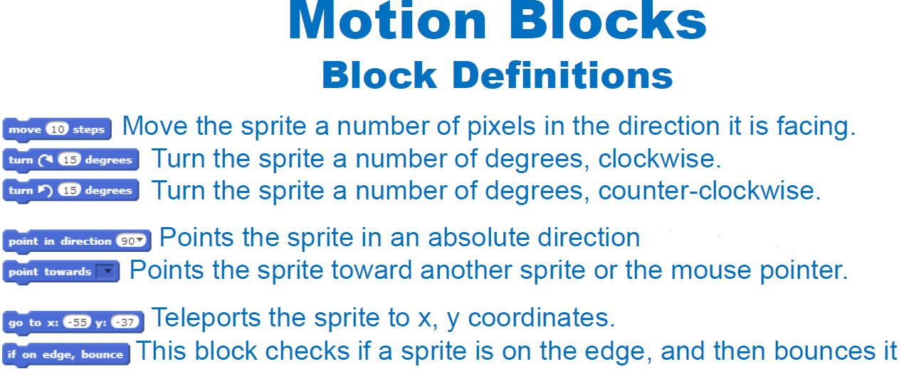

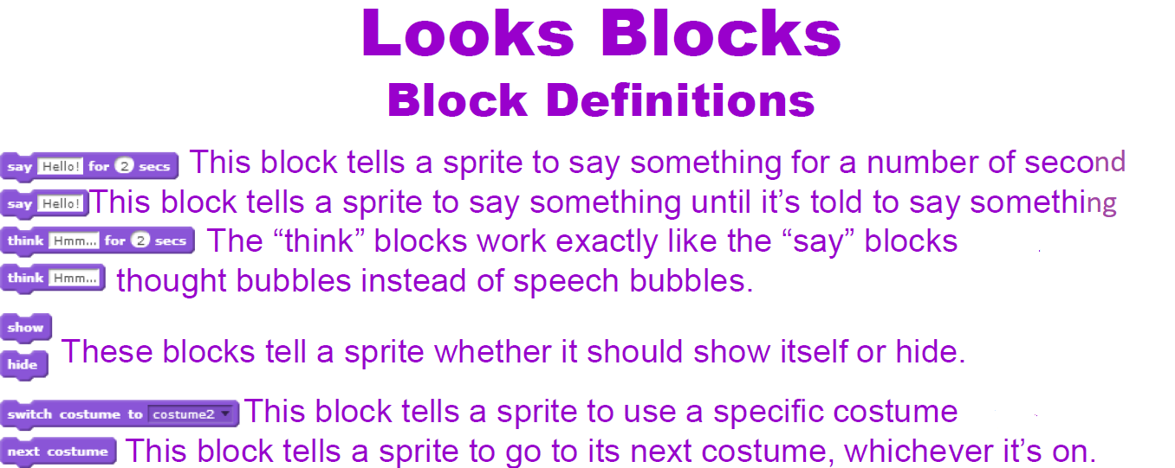

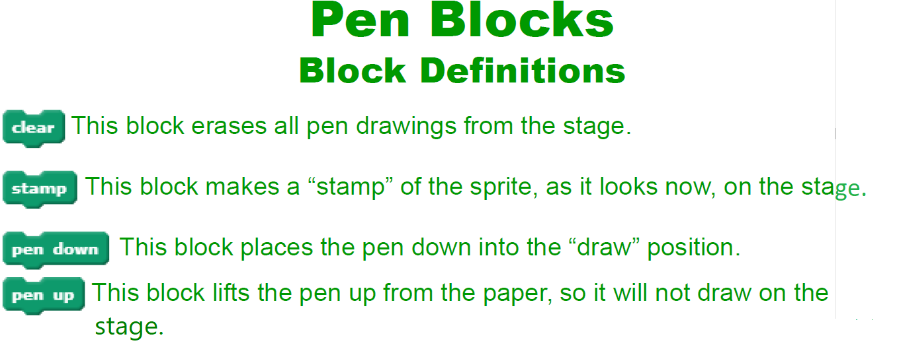

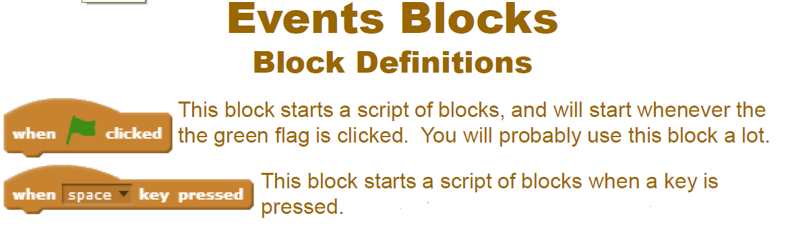

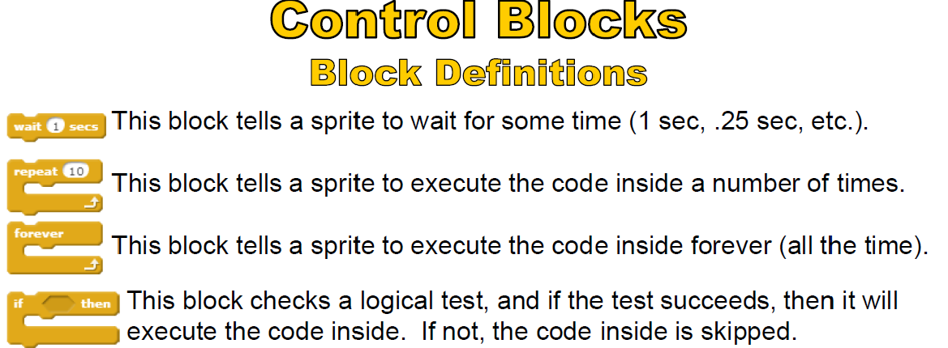

Scratch life cycle.
- What is scratch?
SCRATCH is a programming language that lets you create your own interactive stories, animations, games, music, and art.
- Why we use online scratch?
We use online scratch to create games moves and share with others use it to learn.
- Who is scratch for?
Scratch is for young people age 9 to above.
- Advantages of scratch?
1 thinks faster.
2 solve problems easily.
3 Cooperative learning.
- Main parts of scratch
Background area
Sprite area
Stage
Block or code palate
Coding area
Start
stop
zoon in
zoom out
- What is backpack?
The backpack is a feature of the Scratch 2.0 project editor that allows users to drag and drop costumes, sprites, sounds, and scripts from other projects into it and then drag and drop them easily into their project

- Select from multiple choices.

- What section do you find things to start scripts?
a: Events b: Operators c: Data
- In motion, what type of block do you use to stop sprites coming off the screen?
a: if on edge, set y to change.
b: Set rotation style .
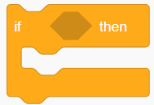
c: if on edge, bounce.
- What blocks do you use for ?
a: Sensing.
b: data.
c: control.
- Scratch is for making programs and sharing your creations?
a: true .
b: false.
c: neither.
- What can costumes do?
a: make more sprites.
b: create blocks.
c: make awesome animations when the right block is used.
- What is motion used for?
a: taking pictures.
b: Moves sprites, changes angles and changes X and Y values.
c: to paint backdrops.
- Complete this sentence-scratch is useful for ________.
a: create movies and games .
b: creating lists.
c: making scripts.
- When clicking on my stuff button, what can you see?
a: scripts
b: previous all projects.
c: the views.

- What is the name of the cat on Scratch?
a: Steve.
b: kitty cat.
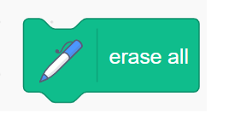
c: sprite 1.
10.What blocks do you use for ?
a: Sensing.
b: pen.
c: control.
11. What are the instructions blocks stored on a scratch screen.
Costume tab
Block palette
Stage
Help tab

12. What is scratch?
A computer project
A computer screen
A programming language
A website

13. What words describes the instructions used to control sprite in scratch.
Backpack
Script
Command
Score
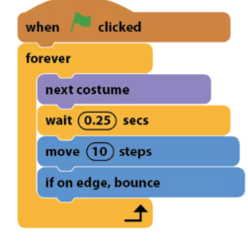

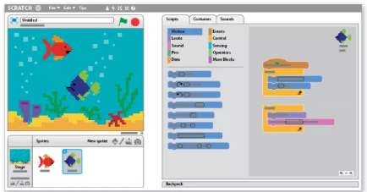
14. What happens if the instruction blocks in scratch are placed in wrong order?
Program will run slow
Program will not work well
Program will run faster
Program will run normally

- word describes characters that can be moved in scratch program?
Gobbling
Sprite
Image

- Which of these functions can a scratch sprite NOT be
Programmed to do?
Play music
Speak
Write a program
Move around screen

- Where are the sprites and scripts stored in a scratch screen?
Background
Stage
Block palette
Backpack

- What would you use to change the location of sprite on the stage in scratch?
Stage information
File menu
Costume tab
Coordinates

- What happens when green flag symbol is clicked in scratch program?
Program start
Program freezes
Program stop
Program is deleted

Category |  | Notes |  | Category |  | Notes
 | Motion | Moves sprites, changes angles and changes X and Y values. |  |  | Sensing | Sprites can interact with the surroundings the user has created
 | Looks | Controls the visuals of the sprite; attach speech or thought bubble, change of background, enlarge or shrink, transparency, shade |  |  | Operators | Mathematical operators, random number generator, and-or statement that compares sprite positions
 | Sound | Plays audio files and effects. Programmable sequences are now available as an extension category named "Music". |  |  | Variables | Variable and List usage and assignment
 | Events | Contains event handlers placed on the top of each group of blocks |  |  | My Blocks | Custom procedures (blocks).
 | Control | Conditional if-else statement, "forever", "repeat", and "stop", etc

