Academic Year 2018-2019 العام الدراسي Grade: 1
Subject: Computer | Computer Revision Sheet | Unit 2 (Microsoft Windows)
- Write the words (desktop – start menu – icons-taskbar ) in the circles
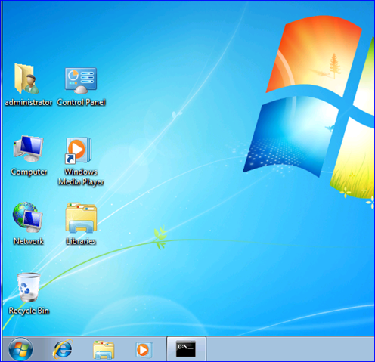

4 text here

3 text here

2 text here

1 text here
United Arab Emirates  Department of Education and Knowledge  Bani Yas International Private School | 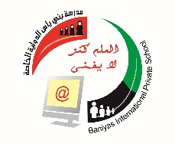 | دولة الإمارات العربية المتحدة  دائرة التعليم والمعرفة  مدرسة بني ياس الدولية الخاصة
The answer :
icons Ic | 1
Desktop | 2
Start menu | 3
Taskbar | 4
State whether true or false :

( true ) 1- we shutdown computer from start menu
( true ) 2- you can close any program from close icon in title bar
( false ) 3- mouse is one of output units
( true ) 4-taskbar is one of desktop components
( false ) 5-To run any program, double click on the right click
( true ) 6-to close correctly your computer, close programs first
( true ) 7- you can drag and drop icons by using mouse
( true ) 8- this called an icon
( true ) 9-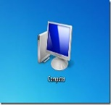 this is my computer icon

( false ) 10- you cannot change icons size in the desktop

Match the picture with the correct name :
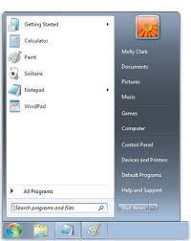
Start menu

Mouse pointer

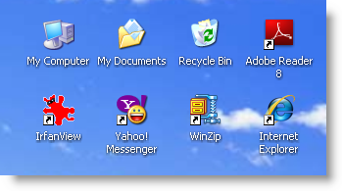

Icons

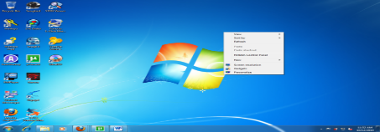
Desktop

Taskbar
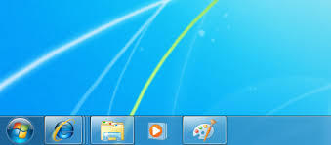

Title bar buttons

To close window

To Restore window

To Maximize window

To Minimize window

